￼

AMRITA VISHWA VIDYAPEETHAM
AMRITA SCHOOL OF COMPUTING, BENGALURU, 560035

The project report entitled “A Graph-Neural Framework for Adaptive Language Reasoning” is submitted by
BL.EN.U4CSE23234 K.Bharath Reddy
BL.EN.U4CSE23249 S J L Vamsi
BL.EN.U4CSE23258 Vundela Lasya
BL.EN.U4CSE23268 Alimili Varshini
as a part of the course 23CSE399 Project Phase 1.

Ms. Pooja Gowda Dr. Gopalakrishnan E.A.
Assistant Professor, Chair
Guide
School of Computing School of Computing

This project report was evaluated by us on ………

Examiner 1 Examiner 2
ACKNOWLEDGEMENTS
The satisfaction that accompanies successful completion of any task would be incomplete without mention of people who made it possible, and whose constant encouragement and guidance have been source of inspiration throughout the course of this project work.
We offer our sincere pranams at the lotus feet of “AMMA”, MATA AMRITANANDAMAYI DEVI who showered her blessing upon us throughout the course of this project work.
We owe our gratitude to Prof. Manoj P., Director, Amrita Vishwa Vidyapeetham Bengaluru Campus. We would like to place our heartfelt gratitude to Dr. Gopalakrishnan E.A., Principal, Amrita School of Computing and Amrita School of Artificial Intelligence, Bengaluru for his valuable support and inspiration.
It is a great pleasure to express our gratitude and indebtedness to our project guide Ms. Pooja Gowda, Assistant Professor , Department of Computer Science and Engineering, Amrita School of Computing, Bengaluru for her/his valuable guidance, encouragement, moral support, and affection throughout the project work.
We would like to express our gratitude to project panel members for their suggestions, encouragement, and moral support during the process of project work and all faculty members for their academic support. Finally, we are forever grateful to our parents, who have loved, supported and encouraged us in all our endeavors.

ABSTRACT

Large Language Models (LLMs) have fundamentally changed the face of AI by giving machines the ability to process, produce and reason about human language. Presently, the foremost transformer-based architectures experience serious limitations in terms of long-horizon reasoning abilities, interpretability, their ability to adaptively manage memory, and their ability to employ biologically-accurate learning techniques. This project will develop, evaluate, and propose biologically inspired architectures for reasoning--in the form of graph-based neural-reasoning models--that replicate the behavior of neurons and synapses in the human brain. The proposed graph-based architecture will use reasoning as dynamic interactions among different graph structures such that neurons are represented as nodes and synapses as the transmission of information from one node to another. This project will emphasize the use of local-to-the-neuron interactions, sparsity of activation, synaptic plasticity, and rapid processing of working memory to enhance both efficiency and interpretability. Attention mechanisms will be applied from a neuro-computational point of view and connected with temporary synaptic strengthening and formation of contextual memories. This project will compare and contrast the architecture, the operational characteristics, advantages/disadvantages, and potential applications for graph models of reasoning, in relation to transformer-based models, with the end goal being a better understanding of language reasoning systems inspired by biology and their potential contribution toward the development of scalable, interpretable, and efficient next-generation artificial intelligence models.

TABLE OF CONTENTS
Page No.
ACKNOWLEDGEMENTS i
ABSTRACT ii
LIST OF FIGURES v or vi
LIST OF TABLES vii
CHAPTER 1- INTRODUCTION ``` 1
  - Introduction To Graph-Based Neural Reasoning
Models 3
  - Motivation 4
CHAPTER 2 – LITERATURE SURVEY 6
  - Review of Large Language Model Architectures 7
  - Transformer Architectures and Attention Mechanisms 8
  - Applications and Challenges of LLMs 9
  - Prompt Engineering and Contextual Learning 10
  - Memory Management and Efficient Inference 11
  - Vision-Language Models and Multimodal Learning 12
  - Biologically Inspired Neural Reasoning Systems 12
  - Summary of Literature Review 13
CHAPTER 3 – SYSTEM REQUIREMENTS AND ANALYSIS 15
  - SOFTWARE REQUIREMENTS 15

CHAPTER 4 – SYSTEM DESIGN 17
4.1 HIGH-LEVEL DESIGN (HLD) 18
4.1.1 Input Processing Module 22
4.1.2 Token Embedding Layer 23
4.1.3 Graph-Based Neuron Networks (GNN) 23
4.1.4 Attention and Synaptic Reweighting Module 24
4.1.5 Inference Engine 25
4.1.6 Dynamic State Memory Module 25
4.1.7 Generation of Output 26
4.2 LOW-LEVEL DESIGN (LLD) 27
4.2.1 Tokenization 29
4.2.2 Embedding Generation 29
4.2.3 Nerve Activation 29
4.2.4 Synaptic Communication 29
4.2.5 Attention Based Method for Reweighting 30
4.2.6 Updating the Context State 30
4.2.7 Prediction of Output 31
4.3 Methodology of Suggested Solution 31
CHAPTER 5 – SYSTEM IMPLEMENTATION
  - Modules Used with Description 33
5.1.1 Introduction 33-34
5.1.2 Input Processing Module 34-36
5.1.3 Embedding Generation Module 36-37
5.1.4 Graph Construction Module 37-39
5.1.5 Attention Mechanism Module 39-41
5.1.6 Inference Engine Module
5.1.7 Dynamic State Memory Module
5.1.8 Output Generation Module
  - Hardware Requirements
  - Software Requirements
  - System Workflow / Execution Flow
  - Advantages of Implementation
  - Summary
CHAPTER 6 – SYSTEM TESTING
6.1 Performance Metrics and Benchmarking
6.1.1 Memory Retention and Context Scaling
6.1.2 Computational Complexity and Scaling (O(N))
6.1.3 Training Throughput and Efficiency
6.2 Stability and Convergence Analysis
6.2.1 Training Stability and Loss Convergence
6.2.2 Gradient Health and Numerical Stability
6.3 Qualitative Assessment of Generative Capabilities
6.3.1 Coherence and Linguistic Accuracy
6.3.2 Comparative Analysis
6.4 Summary of Results

CHAPTER 7– RESULTS AND ANALYSIS
…
CHAPTER 8 – CONCLUSION AND FUTURE ENHANCEMENT …
REFERENCES

LIST OF TABLES

Table 3.1 Software tools and technologies used in the proposed system. ...........16
Table 4.3 Comparison with Traditional Transformer System...............................32
Table 5.2 Hardware Requirements........................................................................45
Table 5.3 Software Requirements.........................................................................46

LIST OF FIGURES

Fig 4.1 High-Level Architecture of BDH System 21
Fig 4.2 Low-Level Architecture of BDH System 28
Fig 5.1 Input Processing Workflow 35
Fig 5.2 Embedding Generation Process 37
Fig 5.3 Graph Construction Process 39
Fig 5.4 Attention-Based Synaptic Reweighting 41
Fig 5.5 Inference Flow in BDH System 42
Fig 5.6 Dynamic State Memory Workflow 43
Fig 5.7 Output Generation Process 45
Fig 5.8 Hardware Environment 46
Fig 5.9 Software Environment 47
Fig 5.10 Execution Workflow of BDH System 48

LIST OF SYMBOLS

$i$- - Source Neuron
$j$- - Target Neuron
$σ$- - connection strength between two neurons.

CHAPTER - 1
INTRODUCTION
Over the last 10 years, AI is being developed at an incredibly rapid rate through many different technologies including:
- improved methods for doing machine learning;
- machine learning using large networks of correlated artificial neural networks or using large multi-layer neural networks;
- large computer systems capable of processing thousands of transactions per second with high reliability;
- model size and data.
Large Language Models (LLMs) have been extremely important to the rapidly growing AI market by enabling AI to function at a level of accuracy comparable to humans when they perform tasks associated with natural language, such as listening, speaking, or interpreting written or typed materials (text, images, audio, etc.) and allowing for the accurate generation of units of natural language.
One of the greatest innovations is the emergence of LLMs that can comprehend and create natural languages with a remarkable degree of precision. They can be utilized for a variety of purposes, including chatbots, virtual assistants, generating content, converting languages from one to another, producing computer code, and recommending products or services intelligently.
Prior to LLMs, the methodologies for recognizing and predicting sequences in natural language were derived from conventional neural network models, including ANNs, RNNs, and LSTMs. While these models have provided some advantages, they also suffered from limitations that made it difficult to maintain long-term dependencies and caused additional difficulties, such as disappearing gradients and limitations in running computations in parallel.
The introduction of the transformer (transformer-based models) changed how NLP is performed by providing an attention-based (parallel processing) architecture in place of the sequential-based architectures of previous generations of neural networks. Self-attention is employed in the transformer model as a means of evaluating the relationship between the words within the input to help determine the contextual surroundings of the input and thus develop a method for efficiently performing operations on large amounts of input data in a manner that has many different formats. The GPT, BERT, and T5 models are three examples of transformer operating at the highest state-of-the-art level for multiple different NLP applications.
Graph-based neural reasoning models can also simulate neuron behavior, synapses, and local neural interactions seen in biological systems. One type of graph-based neural reasoning model will show how reasoning occurs through the dynamic interaction of relative positions of multiple neurons through adaptive synapses. These models are intended to provide a bridge between neuroscientific research and contemporary AI systems, by adopting concepts of 1) Hebbian learning/regressive learning; 2) sparse neuron activation; 3) neuroplasticity/synaptic reorganization; and 4) working memory processes.
The research examines graph-structured neural reasoning architectures, which owing to an analogy with biological neural systems encourage the way one could have local interactions among the neurons resulting in emergent reasoning as opposed to centralized attention-based processes. In performing this task, the investigations of this research examine how attention-based processes theoretically relate with synaptic plasticity, thus providing an exciting biological basis for the understanding of state-of-the-art language models. The framework aims at an enhanced interpretability, more efficient reasoning, and improved scalability while at the same time compatible with modern GPU-based computation systems.
Such research would better position one to understand reasoning models with biological underpinnings, contributing to the development of artificial intelligence systems capable of safely, interpretively, and scalably conducting complex reasoning activities.
1.1 INTRODUCTION TO GRAPH-BASED NEURAL REASONING MODELS
Graph based neural reasoning architectures organize in a manner that mimics the way an animal thinks. The neurons, which represent individual neurons or concepts, are connected to each other via synaptic connections (i.e., edges) on the graph. This is different from the traditional transformer architecture, where the model derives its reasoning capability based on a single global attention matrix across all the data. In contrast, graph-based neural reasoning is dependent on reasoning based on local interactions between connected neurons.
Neurons are activated based on incoming relevant data, and their synaptic connections become stronger or weaker based on their contextual interactions with one another. In this way, graph-based neural reasoning can effectively manage short-term working memory and can reason over multiple steps. Various parameters, such as Hebbian learning, synaptic plasticity, sparse activation, and modularity, all contribute significantly to the nature of the model's learning behavior.
Furthermore, the neurons throughput highly depends on the synaptic connections and interactive behavior with one another, which increases the interpretability of the graph based neural reasoning. It provides information about how a decision and reasoning path is developed, essentially breaking down all of the components in constructing such a path or decision. Sparse neural activation furthermore enables more efficient computation (i.e., lower computational overhead) and ultimately provides greater scalability at larger sized reasoning tasks.
By drawing from a combination of principles from neuroscience, graph theory, and machine learning, graph-based neural reasoning models illustrate an exciting opportunity to advance the field of AI through the development of more efficient and human-like intelligent systems.
1.2 MOTIVATION
The rapid progress of LLMs is indicative of the ability of AI systems to accomplish intricate language processing and generation tasks; nonetheless, many Transformer-based architectures still have limitations related to their ability to reason effectively, their ability to provide meaningful interpretations, their ability to manage long-term memories, and their ability to operate with computational efficiency. The vast majority of contemporary language models are designed as extremely large black-box systems; therefore, the internal reasoning mechanisms of these AI systems are extremely difficult to comprehend and evaluate.
One of the most consequential issues with current AI systems is the inability to reason efficiently over long time periods and adaptively learn from context. Although the use of attention mechanisms may improve contextual understanding, these models continue to depend upon very dense computations and centralized attention structures, both of which become computationally prohibitive as the size of the model increases. Additionally, current architectures do not accurately reflect the local neural interactions and adaptive synaptic behavior observed in biological neural networks.
Highly interconnected neurons that work as a unit via synchronized activity are used in the human brain for a reason. Neurons interact with one another locally (or in the vicinity of) through dynamic synaptic connections. Biological Neural systems have distinctive characteristics like sparse activation, adaptation of memory, synaptic plasticity, and modular organization, which allow for efficient reasoning and learning using far less energy than modern AI systems.
The objective of this project is to investigate biologically inspired neural models (in this case, "neural reasoning architectures") that will connect the fields of neuroscience and AI. Graphs can represent reasoning as a series of dynamic, interconnected elements in the form of neural graphs, which will significantly enhance one’s ability to interpret the activity of a neuron and the connections between them during the process of inference.
There is an increasing need for AI systems to be explainable and trustworthy. As AI becomes more widely utilized in many fields including health care, cyber security, autonomous systems, education and research, understanding how AI makes decisions increases in importance in order to provide accountability and safety. Biologically inspired reasoning models can continue to improve emphasis on the development of AI systems that are transparent or interpretable as well as efficient in terms of computation while still being able to scale. Additionally, this project will look into how these concepts of synaptic plasticity and localized communication between neurons can help create next-generation AGI systems that have greater reasoning and adaptive-learning ability, and improve future language models as well.

CHAPTER - 2
LITERATURE REVIEW

Rapid technological growth in artificial intelligence (AI) and natural language processing (NLP) has resulted in the judicious provision and implementation of large models with capabilities to perform a variety of attitudinally contextualized text-related tasks. Many of these text-based activities are dependent on transformer architectures and attention mechanisms (AMs) which help facilitate the transfer of knowledge from large text-based sources into usable formats using these AMs. Many researchers (academic and non-academic) are currently exploring multiple means of expanding upon the implementation of LLMs that will further enhance their reasoning capabilities, heterodox sources of interpretability, computational efficiency, systematic use of memory, and scalability of how LLMs are constructed. Many researchers are also experimenting with the development of systems founded in the biological sciences to inspire future constructions of LLMs, incorporating sparse and neuro-sparse alternative neural architectures, to graph-based learning systems, in order to typically circumvent the limitations associated with conventional transformer architectures.
The current chapter serves as an in-depth literature review based on existing academic literature dealing with LLMs, transformer architectures, prompt engineering (PE), efficient inference systems, principles of memory optimization (MO), biologically-inspired systems (BIS), graph-system models of reasoning (GSM), and currently related to the overall area of interest to this project. The accompanying literature survey will allow for an active and ongoing dialogue regarding the monitoring of graphical developments within the LLM context and LLM development and/or expansion of traditional transformer architecture methodology.

2.1 Review of Large Language Model Architectures
A thorough overview of LLMs was provided by Rajan et al. [1] through an examination of numerous features such as architecture and application. Additionally reviewed the history of language models beginning with the traditional neural network up to current-day Transformer-based Language Models including GPT and BERT. The authors additionally classified LLMs into categories based on their underlying architecture, training strategies, and application areas such as healthcare, education, cybersecurity, and conversational AI. Moreover, highlighted major challenges facing LLMs such as; the exhibition of hallucinations, computational complexity, ethical issues, bias, and limitations related to interpretability. Overall, they have established a conceptual framework for understanding LLM ecosystems with relevance to applications in the real world.
Another study performed by Rostam et al. [2] systematically reviewed achieving maximum performance from LLMs. Authors analyzed several optimization techniques including Model Scaling, Distributed Training, and Hyperparameter Tuning,HardwareAcceleration,EfficientInferenceTechniques
Through this investigation they were able to evaluate how computational resources in a model contribute to its performance. Additionally, the authors placed a strong emphasis on optimizing memory usage to enable scalable deployments.
This paper contains valuable information regarding how contemporary LLMs can continue to operate at optimized levels even with growing numbers of model parameters.
The work [3] had a comprehensive review on the various architectures of LLMs as well as current advancements in the field; benchmarks used to measure LLMs, technical challenges surrounding LLMs. Using various language models, the authors compared LLMs based on reasoning ability, cost of training, scalability, and ability to understand context. In addition to identifying limitations of LLMs due to the use of dense attention mechanisms and emphasizing the necessity for development of more interpretable and efficient architectures, the work of Shao et al. provides further motivation to explore biological bases of graphic reasoning systems.
Kumar et al. [4] examined the technical frameworks, applications, and challenges for the future with respect to LLMs. Kumar et al. provided an overview of architectural development, while identifying several problems with respect to long-term reasoning capabilities, high computational costs, and lack of explainability for LLMs. Furthermore, Kumar et al. noted a need for further development of adaptive memory architectures and the need to develop efficient neural architectures to perform large-scale reasoning more effectively.
2.2 Transformer Architectures and Attention Mechanisms
Modern language models rely on transformers primarily for their self-attention mechanisms, which allow for fast processing of sequential data. The current body of literature has thoroughly studied both the benefits and drawbacks of transformer-based architectures for language understanding and reasoning applications.
The development of the transformer architecture established the use of self-attention in terms of how each token in a sequence can interact dynamically with every other token in said sequence to produce a representation that reflects the relationships between those tokens based on context. This self-attention mechanism provides a substantial improvement in terms of parallel-processing performance relative to recurrent neural network models. On the other hand, however, calculating dense attention results in many units of memory being used and therefore very high computation power needed, especially when dealing with long sequences of data.
The BDH framework presented in arXiv:2509.26507 [5] reinterprets attention mechanisms from a biologically inspired perspective. This is accomplished through modelling reasoning as local interactions between neurons through adaptive synapses rather than a purely mathematical operation (the matrix product). The emergence of contextual reasoning during inference is explained by using synaptic plasticity and graph-based interactions between neurons. Furthermore, it is suggested that temporary strengthening of synapses can play a role like attention mechanisms utilized in Transformer models.
Additionally, recent research has examined using sparse attention systems along with modularly organized neural processes in order to enhance interpretability and computational efficiency. Sparse neural activation decreases unnecessary computational load by activating only those neurons that are relevant during reasoning tasks. This methodology can be seen within biological neural systems, where often only a small subset of neurons will become activated at any given time.
2.3 Applications and Challenges of LLMs
Hadi and colleagues have authored a very thorough, all-encompassing, literature review as it pertains to Modern-Day Language Models (LLMs), applications in various industries such as, Education, Healthcare, Science, Cyber Security, and Automation. They note that while LLMs exhibit high levels of success across many usage cases, significant challenges remain for LLMs such as instances of hallucinated output, lack of context consistency or security risk inherent in LLM execution or generated output, and the limited interpretability currently available to users of outputs generated by LLMs.
Hadi et al. [6] also present a discussion regarding ethical considerations regarding issues such as misinformation, the presence of bias within and the benign propagation of that bias throughout the LLM life cycle, the potential harm of LLMs with regard to privacy issues, especially when handling sensitive data, and the excessive resources required to execute LLMs in large scale environments. They further emphasize the need for more robust architectures (e.g., safer, more reliable, and more interpretable reasoning architectures) to be developed for future AI systems.
A second example is provided by Fang et al. [7], who present an investigation into the use of LLMs with tabular data to perform prediction, data generation, and the understanding of multiple formats of data in conjunction with performing a highly complex level of task. While these studies give insight into some of the functionality of LLMs, they also provide some context for the types of challenges that can occur when attempting to create a logical level of context when LLMs are processing multiple formats.
2.4 Prompt Engineering and Contextual Learning
Recent advancements in LLMs have necessitated the establishment of the discipline of prompt engineering to enhance the models' reasoning capability, as well as the quality of their outputs. The development of effective prompts will assist the models in identifying desired outputs through the appropriate structure of contextual information.
A survey conducted by Liu et al. [8] provides an overview of existing prompting frameworks used to prompt and evaluate LLMs. Within their analysis, the different types of prompting strategies explored include zero-shot prompting, few-shot prompting (i.e. prompting an LLM with sample inputs), chain-of-thought prompting, and instruction-based prompting. The overall findings of the survey show that well-designed prompts can greatly enhance the accuracy of reasoning, as well as contextual consistency, in the outputs generated by the LLMs.
However, in the process of completing their survey, the authors also identified potential limitations of using prompts, such as the effects of prompt sensitivity and instability of the prompt context. Small differences in the wording of a prompt can result in vastly different outputs. These limitations are indicative of the instability in the internal reasoning processes of current Transformer-based systems, providing an opportunity to examine the development of graph-based neural reasoning systems that utilize dynamic memory systems.
2.5 Memory Management and Efficient Inference
The challenge of effectively managing memory has become increasingly important with the growing size of LLMs. As models continue to grow larger, their ability to run requires greater amounts of memory and resources; thus, both of these areas have become the limiting factors in the use of LLMs at scale. Wenbo et al. [9] have researched how to improve efficiency and reduce memory fragmentation on the GPU for large-scale deployments of LLMs. They proposed a multi-generational approach (i.e., page-aware memory optimizations) that utilizes different techniques to increase inference performance and decrease GPU memory fragmentation during large-scale deployments.
Agrawal et al. [10] developed a new technique, Sarathi-Serve, which allows for optimization of both throughput and latency when using LLMs. Through their surveys and evaluation of available resources, Miao et al. presented large language model service techniques for improving efficiencies in algorithmic use, hardware acceleration (where applicable) and distributed systems/batching methods used to serve users over large geographic areas (LGA) while providing use cases quickly during a period of deployment expansion. [11] The paper also stated that scalable reasoning should occur in an efficient architectural design, minimizing the associated computing budget.
Collectively, these studies suggested that future language model architecture development requires consideration of how to efficiently manage memory and utilize sparse compute methods.
2.6 Vision-Language Models and Multimodal Learning
Numerous visual learning systems have integrated with LLMs to develop the latest generation of multimodal AI architectures that can understand both visual and textual data. In their research work, Alayrac [12] presented Flamingo - a visual language model created for few-shot learning tasks that utilize multiple types of input data (text and images). The design incorporated transformers for language and vision processing into one model. The research demonstrated strong results in three areas: producing captions based on images, answering visual questions about images, and reasoning across multiple data types.
The results achieved by these multifunctional models highlight the need for flexible reasoning-based architectures as they will aid in combining various modalities of information into an overall context. As researchers develop graph-based reasoning systems and biologically inspired models, they will likely become more sophisticated at context-sensitive integration and supporting future advancements in adaptive learning methodologies of multimodal AI systems [13].
2.7 Biologically Inspired Neural Reasoning Systems
There has been a recent increase in the amount of academic work that has researched biologically based AI systems and how they replicate how neurons communicate with each other, as observed within the human brain.
The BDH framework [5,14] allows for the use of a graph-based reasoning architecture that utilizes dynamic interaction between neurons and synapses to complete reasoning tasks. In contrast to traditional Transformers that rely on a central attention matrix, BDH models reasoning through local interactions between biological neurons that utilize biologically based rules of interaction.
In addition, the BDH framework separates long-term models stored in parameters and short-term models in the rapidly changing synaptic states or working memory [15]. This separation of long-term and short-term memory is like how biological systems employ synapses to create learning and reasoning.
The study also stressed the importance of sparse activation and a modular organization of neurons, which enhances both computational efficiency and interpretability [16]. Biologically based modelling is seen as a positive step forward towards creating scalable, explainable, and safe AI systems.
2.8 Summary of Literature Review
According to literature, significant advancements have been made in Natural Language Understanding, Generation and Reasoning tasks with the emergence of LLMs. A large fraction of AI systems utilizes a Transformer-based architecture and the attention mechanism. Although much progress has been made with LLMs, there remain limitations in their Interpretability, Computational Complexity, Working with Memory, Contextual Consistency and Long-Horizon Reasoning.
Research trends are shifting towards the use of Sparse Neural Architectures, Efficient Memory Management, Prompt Engineering, Multimodal Reasoning, and Biologically Based Learning Systems. Due to the development of Graph Based Neural Reasoning Frameworks and Synaptic Plasticity Models, we can develop more interpretable and scalable forms of Reasoning Systems like Reasoning Systems of Biological Neural Intelligence.
The literature review shows that there is a strong need to explore Biologically Based Graph Based Reasoning Architectures if we wish to improve efficiency, Adaptive Learning, Memory Management, and Interpretability in Future AI Systems.

CHAPTER – 3

SYSTEM SPECIFICATIONS

Requirements for the proposed system will consist of hardware resources and software applications that will enable system architects to design an efficient and effective graph-based neural reasoning framework that will ultimately provide an avenue for the creation and analysis of biological language reasoning systems via AI technologies and simulation systems. Hardware resources and software applications will play an important role in the efficient analysis of neural architectures, attention mechanisms (weighted/similarity-based), graph-based reasoning models, and the behaviors of language models. A major aspect of the hardware and software requirements will include the computational requirements of LLMs and graph-based reasoning systems, as they have computationally intensive processes for both execution and experimentation.

3.1 Software requirements
In addition to the above needs, the proposed system's software requirements will represent programming languages, programming environments, libraries, frameworks, and operating systems needed to successfully implement and analyse the proposed systems. The primary focus of the software tools required is based upon AI and machine learning frameworks supporting neural computation, graph modelling, and reasoning analysis activities.
The software tools and technologies used in implementing the proposed system include:

Sl. No | Software/Tool | Purpose
1 | Python | Core Programming Language Used to Implement and Analyze
2 | PyTorch | Deep Learning Framework Used to Build Neural Networks
3 | TensorFlow | Machine Learning Framework Used to Experiment with Models
4 | NetworkX | Graph Modelling and Analysis of Graph-Based Neural Interaction
5 | NumPy | Numerical Computation and Matrix Manipulation
6 | Matplotlib | Data Visualization and Graphical Analysis
7 | Google Colab | Cloud-Based GPU Run Environment
8 | Visual Studio Code | Source Code Development and Debugging
9 | Jupyter Notebook | Interactive Experimentation and Model Testing
10 | Microsoft Word | Documenting and Preparing Reports
11 | Windows/Linux Operating System | Platform Development and Runtime Env

Table 3.1 software tools and technologies used in the proposed system.

CHAPTER - 4
SYSTEM DESIGN

The proposed graph-based neural reasoning framework has a system design which includes the architecture, the operational workflow, as well as the internal interaction mechanisms of the proposed reasoning framework. The proposed reasoning system includes concepts from neural computation, artificial intelligence, graph theory, as well as biologically based reasoning architecture. The system is designed primarily by representing reasoning through the relational dynamic interactions between neurons and between synaptic connections, instead of centrally using attention as the only mechanism for processing information, which is what traditional transformer models do. The entire system architecture will be composed of multiple modules that interact to perform the following functions: input processing, building graphs, activating neurons, updating synapses, reasoning via sparsity (information processing), maintaining contextual memory, and producing an output to be sent to a user.

Furthermore, to support the overall system, biological inspired reasoning concepts have been integrated into the system's design, such as synaptic plasticity; local neuron to neuron communication; sparse activation this process is also referred to as distributing the workload over multiple locations and adaptive working memory.

To facilitate the understanding of the system, the overall proposed design has been broken down into two major design levels:

1. High-level design
2. Low-level design
These design levels represent the conceptual flow of the reasoning process as well as detail the specific internal mechanism(s) of how the reasoning process will occur.
4.1 HIGH-LEVEL DESIGN (HLD):
The High-Level Design (HLD) of the proposed BDH (Dragon Hatchling) architecture consists of a complete description of the overall structure and architecture of the system, major modules and components of the system, communication flow through the system, and reasoning mechanisms that occur during execution. The BDH system is a biologically inspired, graph-based reasoning framework developed to overcome some of the limitations of traditional Transformer-based architectures. The BDH system derives its ideas from a combination of Artificial Neural Networks, Graph Theory, Synaptic Plasticity, and Attention Mechanisms.
Traditional Transformer models generally require that dense matrix computations and global attention mechanisms be used to process information regarding context. Even though traditional Transformer models have demonstrated an ability to perform very well, these models have deficiencies such as poor interpretability, high computational complexity, high memory requirements, and inefficiency when reasoning over long time horizons. The proposed BDH system offers neuron-like graph structures where reasoning occurs through the localized interaction of neurons in the network and through dynamic communication with each other through connections (synapses) that change as the inference occurs based upon attention state reweighting.
The BDH architecture is based on a distributed(graph-based) processing paradigm in which neuron nodes communicate using weighted connections(synapses). During the inference process, the synapses are continuously updated through attention-based state reweighting's. This dynamic processing makes it possible for the BDH architecture to maintain the representational continuity of the element(s) in the system, thus increasing the ability of the BDH architecture to reason over long historical sequences of tokens (words).
The High-Level Design concentrate on:
- The entire architecture of the system
- Functional sections
- Data transfers between each functional section
- Interconnected neural networks
- Mechanisms for contextual reasoning, and
- Processes for updating memory.
The complete architecture for the system will consist of these major modules:
- An Input Processing Module
- The Token Embedding Layer
- A Graph-Based Neural Network
- An Attention and Synaptic Reweighting Module
- An Inference Engine
- Dynamic State Memory, and
- An Output Generation Module.
Each of the above modules has a distinct purpose that allows them to work together as a single unit to provide distributed reasoning and contextual inference capabilities.
Overview of Architecture at High Level
This is a high-level overview of the proposed BDH architecture:
The BDH's Input Processing Module is where the raw user text is cleaned up, normalized, and converted to structured tokens. The structured tokens are then forwarded into the Token Embedding Layer, which will convert the structured tokens into their associated high-dimensional vector representations. The embedding vectors will retain the semantic relationships between the words in addition to providing meaningful numerical representations of those words for future processing. The generated embeddings will be forwarded into the Graph-Based Neuron Network, which is the core computational structure of the BDH architecture. The neuron nodes within this network communicate with one another through weighted synaptic edges. Unlike the fully connected Transformer attention mechanisms, the BDH architecture has sparse and localized neuron interactions; this has the effect of reducing unnecessary computational overhead.
The Attention and Synaptic Reweighing Module dynamically adjusts the weights of the synapses as a function of contextual significance and the patterns of activation of the neurons. This is inspired by the biological Hebbian principles of learning where neurons that activate together strengthen their connection with one another over time. The reasoning operations of the Inference Engine occur via the propagation of neuron activations through graph structures. The states of the neurons are continually developing during inference as a result of incoming signal and contextual memory. The Dynamic State Memory Module stores temporary context information and updates memory states dynamically as the reasoning operation progresses. This enables improved long horizon reasoning capabilities and retention of contextual information.
Finally, the Output Generation Module will decode the final neuron activation states into human-readable textual formats, which will subsequently be produced as an output to the user.
The architecture provides the ability to support:
- Distributed Reasoning
- Sparse Activation
- Dynamic Contextual Memory
- Localized Computation
- Interpretability of Neuron Interactions
- Scalability of Graph Processing
High-Level Architecture
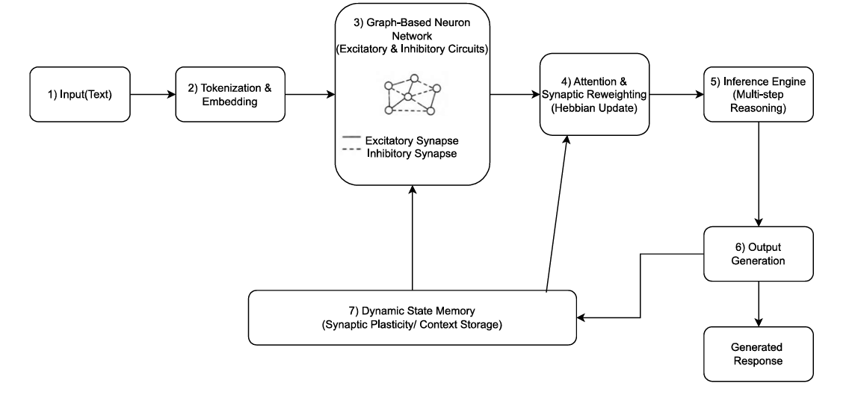
Fig 4.1 High-Level Architecture of BDH System
Figure 4.1 displays the overall structural image for the BDH system and how it interacts through its principal module sections. The architectural process starts with the processing of user input data. All Textual user input is converted to machine-readable tokens. The output tokens are converted to form semantic embedding and used as inputs into the neuron network based on its graph structure. Once they enter the neuron network, the neuron nodes communicate with each other over synaptic edges that have been weighted according to the “contextual importance” at each moment. The Attention and Synaptic Reweighting Module applies algorithms that modify the weights of each synaptic edge dynamically as dictated by the information in the context. Once the weights are adjusted, the inference engine can propagate the activations from the neuron nodes through the neuron pathways, creating multiple layers of reasoning.
The Dynamic State Memory Module continually tracks and updates the reasoning operations of the contextual information through the reasoning process, allowing the system to maintain long-term dependencies between tokens and ensure the continuity of its reasoning. When the neuron activations have been processed in the neuron network, they will be used as the input to the Output Generation Module where they will be decoded back into Textual outputs.
This diagram provided describes the biologically distributed architecture of the BDH System.
4.1.1 Input Processing Module
The Input Processing Module is the first part of the BDH system. It gets a user’s input, which in this instance is text, and then completes the preprocessing tasks so that the machine can understand it.
Before processing user input via the BDH system, it is necessary to preprocess the input since natural language contains novel characters and inconsistent formatting, which makes processing less efficient. Preprocessing the input before doing subsequent computations is accomplished via standardizing the user’s input.
The following operations are performed in the Input Processing Module:
- Tokenizing
- Noise Removal
- Normalization of the input
- Segmentation of the input
The tokenization operation breaks the input into smaller components called tokens. The noise removal removes unwanted characters and symbols; the normalization of the input makes sure that the text conforms to the expected format so that it can be processed consistently by the BDH system; and the segmentation of the input makes large groups of sentences easier to manage by breaking them up into smaller groups (i.e., this is the purpose of segmenting the input into smaller groups). The preprocessed data that has been generated by the Input Processing Module is suited for use in the BDH system since it is structured, has been cleaned, and is fit for converting into a vector, which is nested (as in an array) within the BDH system.

4.1.2 Token Embedding Layer
The Token Embedding Layer is used to take a raw input of text and create a dense vector (often referred to as an embedding) which represents the input in a high dimensional space. Since computers cannot comprehend language directly, the only way to represent words in a manner that a computer can process is mathematically. The Token Embedding Layer maps each token from the raw input to a semantic vector space. Within that space, numerical representations of similar words will be close together or related (i.e. words that have similar meanings will be close to one another in semantic vector space); and this mapping is called embedding.
Based on this concept of embedding, the following features will be preserved in the token embedding layer:
- Semantic Similarity
- Contextual Meaning
- Linguistic Relationships
- Feature Information
The embedding vectors generated by the Token Embedding Layer are used by the graph network as an input to the neuron node and thus significantly impact reasoning performance and contextual understanding. The embedding layer allows for increased understanding of how words relate to one another and how concepts relate to one another through inference.
4.1.3 Graph-Based Neuron Networks (GNN)
The Graph-Based Neuron Network is the primary computational construct of the BDH architecture. The BDH architecture employs a graph topology to link all neurons. The key difference between traditional Transformer systems and the BDH system is that all operations are conducted using graph-connected neuron nodes, while traditional Transformer systems use dense attention properties.
The elements of the graph topology include the following:
- Neuron nodes
- Synaptic edges
- Excitatory circuits
- Inhibitory circuits
Each neuron's local computations take place using the weights assigned to the synaptic edges connecting the neuron to adjacent neurons. The graph's connectivity pattern is defined by sparse connections across the graph, thereby reducing the number of computations while preserving the ability to perform reasoning.
The following functions are performed with GNNs:
- Distributed computation
- Sparse activation
- Localized reasoning
- Scale-free graph topology
The graph topology used in the GNN architecture provides greater interpretability and scale by enabling reasoning to occur from neuron connections rather than global, dense computation.
4.1.4 Attention and Synaptic Reweighting Module
Attention and Synaptic Reweighting Module helps guide the BDH architecture's contextual reasoning. This module will adjust the neuron synaptic strengths dynamically based on the relevant activation of the neurons and the contextual importance of both activation and neuron.
When two neurons activate at the same time, the strength of connection between them will increase based on the principles of Hebbian Learning:
"Neurons that fire together, wire together"

The module accomplishes:
- Adjusting synaptic weights
- Computing attention scores
- Reinforcing context
- Enhancing relevant paths
- Suppressing irrelevant signals
The attention mechanism allows the system to pay more attention to the relevant contexts and reduce the activation of unnecessary neurons. This reweighting allows for more context memory retention and continuity in reasoning.
4.1.5 Inference Engine
The Inference Engine (IE) implements reasoning functions on top of the graph-based neuron network by distributing activation signals through neuron pathways while continuously updating the state of neurons during inference.
Overall, the inference process comprises:
- multi-step reasoning
- propagation of activation
- contextual inferences
- generation of decisions
The reasoning performed occurs through many cycles of interacting neurons. Activated neurons send activation signals to neighbouring neurons through synapses (also known as synaptic connections). The amount of signal that is sent from one neuron to another depends on the weight of the synapse and the relevance of the activation. The Inference Engine (IE) provides a means for the BDH system to process complex contextual relationships and provide meaningful results, through distributed computation.
4.1.6 Dynamic State Memory Module
The Dynamic State Memory (DSM) Module is the location for temporary contextual information produced during the process of reasoning operations. While conventional Transformer KV-caches maintain static memory structures, in BDH architecture, the memory structure is continuously changed as synaptic memories increase with inference.
The DSM Module can support the following:
- temporary context storage
- continuous dynamic updates of memory
- long range contextual retention
- synchronization of states
Memory states are continuously updated as neurons interact, which results in better long-sequence reasoning capability, and less loss of contextual information during inference. The Dynamic State Memory (DSM) Module allows the BDH system to maintain contextual continuity throughout long periods of time while reasoning.
4.1.7 Generation of Output
Finally, the Output Generation Module transforms the final neuron activation states into human-readable textual output. When reasoning operations are done , the inference engine produces activation values that are decoded into probability distributions over possible output tokens.
The module does:

- Generating probabilities
- Predict token
- Decoding of responses
- Generating sentences

The output is the token with the highest contextual probability. Multiple predicted tokens are combined to produce coherent text responses.
This module acts as the last communication layer between the user and the BDH system.
Benefits of Proposed High-Level Design
The proposed BDH High-Level Design has multiple advantages over traditional Transformer architectures. The graph-based neuron interaction model improves interpretability by enabling localized reasoning and observing communication between neurons. Dynamic synaptic memory improves contextual continuity and long-horizon reasoning capability. Sparse graph connectivity lowers computational overhead and enhances scalability.
The distributed reasoning mechanism closely mimics the behaviour of biological neurons, making the system more adaptable and context-aware. The architecture also alleviates the need for extremely large parameter scaling while maintaining strong reasoning ability.
The main advantages are:
- Enhanced interpretability
- Dynamic Contextual Memory:
- Improved long-horizon reasoning
- Less reliance on scale parameterisation
- Distributed computation inspired by brain
- Graph architecture that scales
4.2 LOW-LEVEL DESIGN (LLD):
The Low-Level Design is about the workings of the BDH architecture. It tells us how different parts of the BDH system work together. The High-Level Design looks at the picture, but the Low-Level Design looks at the small details. It explains how each part of the system does its job talk to parts and makes decisions.
The Low-Level Design looks at things like:
- data structures
- How neurons are activated
- How neurons talk to each other
- How the system updates its information
- How the system pays attention to things
- How the system keeps its memory in sync
- How the system makes decisions
The BDH system uses neurons to reason and make decisions. Each neuron has its information about how strong it is and what is going on around it. The connections between neurons change based on how they talk to each other and what they are paying attention to.
The Low-Level Design helps us understand how the BDH system uses neurons and connections to make decisions and reason. It shows us how the Low-Level Design of the BDH system works and how that helps the system think and make decisions. The Low-Level Design of the BDH system is important because it helps us see how the BDH system really works, by looking at the Low-Level Design.
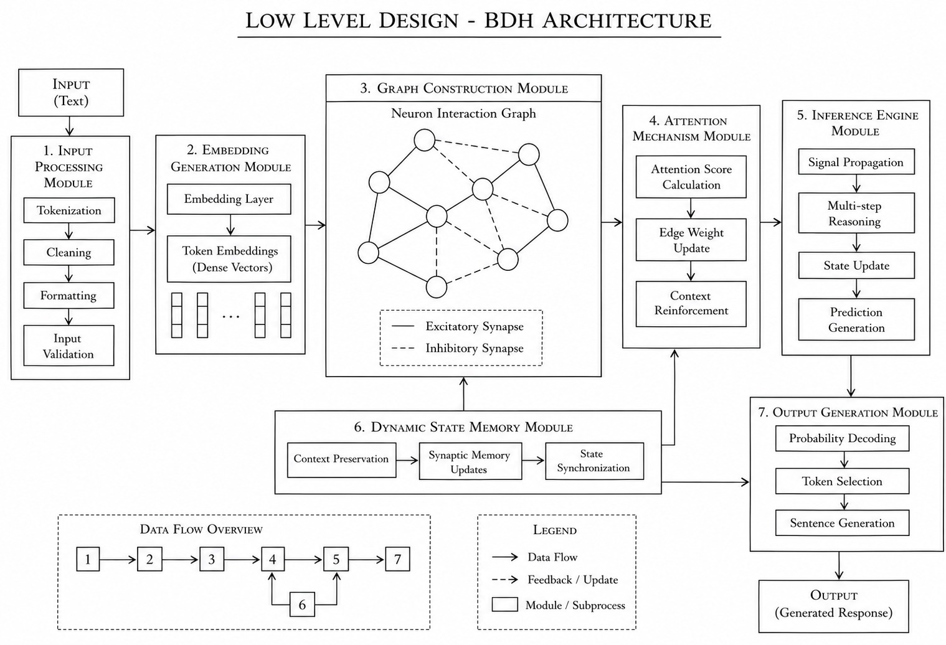
Fig 4.2 Low-Level Architecture of BDH System
Figure 4.2 illustrates that neuron nodes send and receive signals through edges, with different weights. Each neuron gets some input. Calculates how relevant it is. The attention mechanism then changes the strength of these connections based on how active the neurons are activated they send signals to their neighboring neurons. This process helps patterns of reasoning emerge as the signals move through the graph. The figure also shows how the memory states are updated continuously during inference operations. The contextual memory states keep changing as the BDH architecture processes information. This continuous update helps the BDH architecture to make decisions.

Internal Workflow of BDH System

The operation of the B.D.H. system is similar to a traditional workflow; however, its primary difference lies in its method of handling input.

4.2.1 Tokenization
The first step in this process is to break down the text into its base components or 'tokens'. Using the example provided above (the sentence "Explain Artificial Intelligence"), the input is broken down as follows:

Input: "Explain Artificial Intelligence"
Generated Tokens: 'Explain', 'Artificial', 'Intelligence'

These tokens now act as the basic units of process for the remainder of the workflow.

4.2.2 Embedding Generation

Once the tokens are created, each of the generated tokens is represented as a high-dimensional vector embedding. The semantic relationships and context associated with each token are contained within the newly created embedding as follows:

$$Token→Vector Representations$$

The newly created vector representations are then used as inputs to activate neuron nodes in the graph network.

4.2.3 Nerve Activation

The nerve nodes are fed an input signal of an embedding vector. Each nerve determines the following for the embedding vector:

- Activation Strength
- Contextual Relevance
- Neighbor Influence
- Signal Priority

The Nerve Activation Function will decide if a nerve will propagate its signal to its neighboring nerves. When a nerve activates, it will become a part of the Reasoning Path during Inferring.

4.2.4 Synaptic Communication

Once activated, nerves communicate with each other using their Synaptic Weights through Weighted Synapse Connections. Communication types of use:

- Excitatory Signals
- Inhibitory Signals

The use of Excitatory Signals increases the activation strength of neighboring nerves, while the use of Inhibitory Signals reduces the activation strength of irrelevant nerves.

Synaptic Weights will determine the following:

- Signal Strength
- Communication Priority
- Contextual Influence

This method of interacting between nerves is how distributed reasoning is achieved throughout the Graph Network.

4.2.5 Attention Based Method for Reweighting

The Attention Module continually adapts the synaptic weights of a neuron during inference, based on the activity of the context.

The update of the synapses follows a Hebbian learning dynamic

$σ\left(i,j\right)=σ\left(i,j\right)+Y\left(i\right)x\left(j\right)$

Where:

- $σ\left(i,j\right)$ = The synaptic weight of the two neurons
- $Y\left(i\right)$ = The output activation of neuron i
- $X\left(j\right)$ = The input activation of neuron j

This relationship increases the strength of the synapse connecting these neurons when they frequently activate together. The process of continual reweighting of synapses results in improved retention of the experience related to context and the ability to continuously reason based on context.

4.2.6 Updating the Context State

The Dynamic State Memory Module is continually updating context information during all reasoning processes.

Information related to states of memory is:

- Past activations of neurons
- Relationships between the context and now
- The pathway taken to reason
- The history of synapses

These states of memory are repeatedly refined through the course of the inference process. The adaptive nature of the memory allows the BDH system to maintain its ability to reason over extended contexts.

4.2.7 Prediction of Output

Once the reasoning has been done, the ultimate neuron output states will be decoded into output tokens.

The Module for Output Generation calculates the probability distribution of potential output tokens and chooses the token with the greatest probability to be the expected output.

The sequence of generated tokens will be joined together in the same order they are produced, resulting in a final textual reaction to the user.

4.3 Methodology of Suggested Solution
The suggested solution proceeds as follows:
1. Text input is entered by the user
2. The text is broken into tokens and embedded
3. A neural graph structure is created
4. Synaptic relationships are established
5. Relevant neurons are retrieved and activated
6. Synaptic weights are updated on an ongoing basis
7. Reasoning is done using sparse propagation of information
8. Contextual output is produced
This methodology allows for a biologically motivated strategy to produce reasoning through graph-based neural connection(s).

Comparison with Traditional Transformer Systems

Feature | Transformer Model | Proposed Graph-Based System
Attention Type | Global Attention | Local Synaptic Interaction
Memory Handling | KV Cache | Synaptic State Memory
Activation | Dense Activation | Sparse Activation
Interpretability | Limited | Improved
Biological Similarity | Low | High
Reasoning Style | Matrix-Based | Graph-Based\

Table 4.3 Comparison with Traditional Transformer Systems

The new design for the system uses a biological inspired graph method that can do contextual reasoning using local neuron-to-neuron interaction and adaptive synaptic communication between neurons. The High-Level Design explains the way in which the workflow happens, and how the modules will interrelate with one another, while the Low-Level Design will explain the ways in which neural reasoning and contextual memory manipulation will occur internally. The architecture intends to be more interpretable, more efficient at sparse reasoning, and closer to how humans understand language compared to existing Transformer-based architectures.

CHAPTER – 5
SYSTEM IMPLEMENTATION

5.1 Modules Used with Description
5.1.1 Introduction
During the implementation of the BDH Architecture, the project was converted from a proposed architecture into a functional Reasoning Framework that could provide both Contextual Understanding and Intelligent Response Generation. The development of the System was based upon the high-level design and low-level design previously discussed within Chapter 4 of this document.
The System was created using Graph-based Reasoning methodology whereby Neuron-like Nodes communicate via Weighted Synaptic Connections. The System combines the following Methods into one Single Architecture; Text Pre-processing; Embedding Generation; Graph Construction; Dynamic Attention Computation; Distributed Inference; Adaptive Memory Handling.
Unlike Conventional Transformer Systems, which rely on Dense Tensor Combinations for their calculations; The BDH System utilizes a Sparse Graph Processing Approach to Performing Reasoning as based on the way in which Biological Neurons Communicate with one another. Therefore, the System can maintain Contextual Continuity while eliminating unnecessary computations.
Key Features of the Implementation: -
- Efficient Processing of Long-Range Contextual Sequences
- Support for Distributed Interactions Between Neurons
- Dynamic Updates of Contextual Memory
- Continuity of Reasoning from Previous Things to New Ones
- Localized Inference Based on Graphs
- Reduced Computational Overhead via Sparse Connections

The Entire Implementation is Composed of a few Interdependent Modules. Each of These Modules Performs a Particular Function and Communicates with Neighboring Modules During Execution.
The Major Components Implemented in the System are
1. The Input Processing Module
2. The Embedding Generation Module
3. The Graph Construction Module
4. The Attention Mechanism Module
5. The Inference Engine Module
6. The Dynamic State Memory Module
7. The Output Generation Module
5.1.2 Input Processing Module
The purpose of the Input Processing Module (IPM) is to be the initial step of the BDH system. It accepts textual input from the user and transforms it into a computational format that can then be used for calculations. An input from a user may contain unwanted symbols, punctuation, uneven space between words, or inconsistent formatting; therefore, preprocess must be performed on the data before proceeding with reasoning processing.
The input into the system will be pre-processed into filtered and standardized data that will ultimately be used for generating an embedding and implementing a graph reasoning algorithm.
The IPM has some special functionalities that include:
Tokenization: The input sentence will be separated into smaller sections called tokens.
Cleansing: The input will be cleansed by removing whitespace, special characters, invalid characters, and unwanted noise.
Format: The text will be formatted in all lowercases, normalizing sentences, and formatting them properly.
Validation: The following conditions will be validated by the IPM before embedding generation:
1. Empty input.
2. Invalid character usage.
3. Input length.
Tokenization Formula
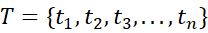(1)
Where:
- represents the complete set of tokens
- represents an individual token
The tokenization formula represents the process of splitting the input sentence into multiple smaller units. These tokens become the basic processing elements used throughout the BDH reasoning architecture.
Technologies Used
- Python
- NLP Libraries
- Regular Expression Processing

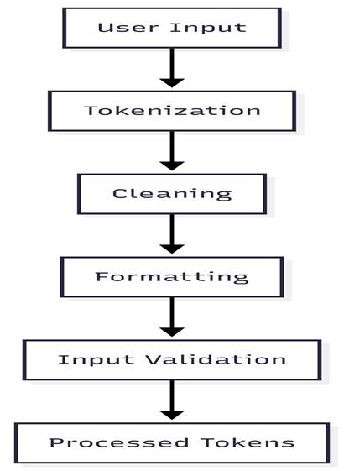
Figure 5.1 – Input Processing Workflow
Figure 5.1 illustrates the sequence of operations performed inside the Input Processing Module. The raw input entered by the user undergoes tokenization, cleaning, formatting, and validation. The processed tokens generated by this module are forwarded to the embedding generation stage.
5.1.3 Embedding Generation Module
The Embedding Generation Module transforms words into numerical vectors called embedding. Words cannot be processed by computers; they are converted into mathematical vector representations prior to using those representations for operations that require reasoning.
The embeddings created using this method will contain the semantics of the words and the relationship of context among the words. Words that are closely related will have vectors that are close to one another in a multi-dimensional vector space.
The embeddings from this module act as activation signals to the neuron node in the graph-based reasoning architecture.
The functions of the Embedding Generation Module include: -
- Semantic Encoding Capture the semantics and context of tokens that are used when generating outputs.
- Transformation Converts tokens into high-dimensional numeric vectors.
- Feature Representation Stores the following quantities:
  - Semantic relationships
  - Similarity between words
  - Context in which words occur
  - Linguistic characteristics
Embedding Representation Formula
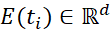(2)
Where:
- 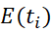represents the embedding vector of token
- represents embedding dimension

Cosine Similarity Formula
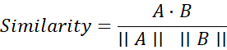 (3)
Where:
- and represent embedding vectors
- 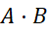represents dot product
- represents vector magnitude

The cosine similarity formula measures semantic similarity between embedding vectors. Tokens with similar meanings produce vectors with higher similarity values.
Technologies Used
- PyTorch
- Embedding Layers
- Tensor Operations
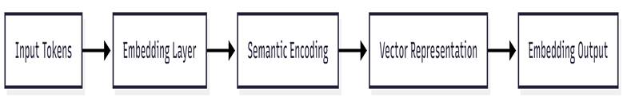
Figure 5.2 – Embedding Generation Process

Figure 5.2 illustrates the embedding process. Input tokens are converted into semantic vector representations through embedding layers and tensor operations. These embeddings become activation inputs for neuron nodes inside the graph network.
5.1.4 Graph Construction Module
The module for constructing graphs is the primary structural component of the architecture of the BDH. The neuron interaction graph is built by this module, where neuron nodes send messages to each other using weighted synaptic edges. Transformers depend on an attention matrix that connects all neuron nodes; therefore, all neuron nodes are fully connected. The BDH does not rely on fully connected attention matrices but instead relies on a graph connectivity pattern to determine the reasoning pathways and the relationships between information in a context.
The graph enables localized interactions of neurons to form a distributed capacity for reasoning.
Functions of the Graph Construction Module
- Node creation
- Neuron nodes are created to signify embedded activations.
- Edge initialization Synaptic edges that connect neuron nodes will be given weight.
- Graph topology generation
The graph enables:
- Sparse connectivity
- Distributed system
- Scale-free topology

Graph Representation Formula
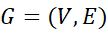(4)
Where:
- represents graph structure
- represents neuron nodes
- represents synaptic edges

Adjacency Matrix Formula
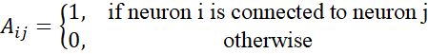(5)
The graph formula defines neuron connectivity inside the BDH architecture. The adjacency matrix determines whether communication exists between two neuron nodes.
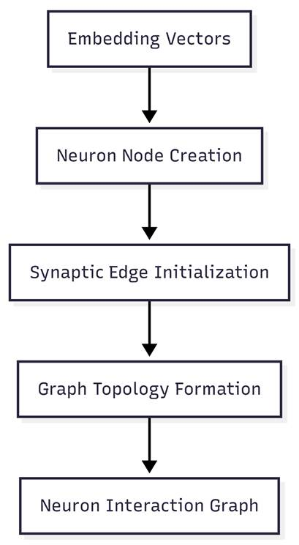
Figure 5.3 – Graph Construction Process
Figure 5.3 illustrates the construction of the neuron interaction graph. Embedding vectors activate neuron nodes, and weighted synaptic edges are established between contextually related neurons.
5.1.5 Attention Mechanism Module
The Attention Mechanism Module performs dynamic synaptic re-weighting at inference time. This module recognizes how context modifies the relationship between neural units and updates the connection weights of synapses as appropriate. This is done according to biological-based principles of synaptic plasticity, which suggest that repeated activation of neuron groups strengthens the corresponding communication pathways.
Functional Elements of the Attention Mechanism Module
- Attention Score Calculation
- Calculates the degree to which one neuron is contextually important relative to another.
- Synaptic Weight Update
- Dynamically modifies the edge weights between neurons while engaging in inference.
- Reinforcing the Context
- Reinforces the pathways that are critical to establishing reasoning.

Attention Formula
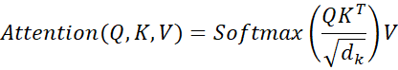 (6)
Where:
- represents Query matrix
- represents Key matrix
- represents Value matrix
- represents key vector dimension

Synaptic Update Formula
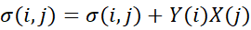 (7)
Where:
- 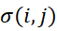represents synaptic weight
- 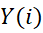represents output activation
- 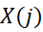represents input activation

The attention mechanism computes the contextual importance of scores between neurons. The synaptic update formula strengthens neuron connections according to activation patterns during reasoning.


Figure 5.4 – Attention-Based Synaptic Reweighting

Figure 5.4 illustrates how attention scores dynamically modify synaptic weights during reasoning operations. Strong contextual relationships produce stronger synaptic connections.
5.1.6 Inference Engine Module
The Inference Engine Module uses multiple interactions of Neurons and multiple cycles of Signal Propagation to perform reasoning processes that are both iterative and distributed.
Functions of the Inference Engine Module include:
- Multi-Step Reasoning: Performs sequential reasoning across edges of multiple Graphs.
- Signal Propagation: Propagates the activation of Neurons between one another.
- State Updates: Refreshes the state of each Neuron during Inference.
- Prediction Generation: Generates contextual predictions based on the activation of Neurons.

Neuron Activation Formula
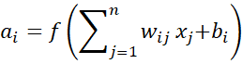 (8)
Where:
- represents neuron activation
- represents synaptic weight
- represents input signal
- represents bias term
- represents activation function

Signal Propagation Formula
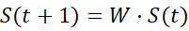 (9)
Where:
- 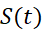represents current neuron state
- represents weight matrix
- 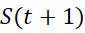represents updated neuron state

These formulas calculate neuron activation strength and signal propagation during reasoning operations across graph-connected neuron structures.
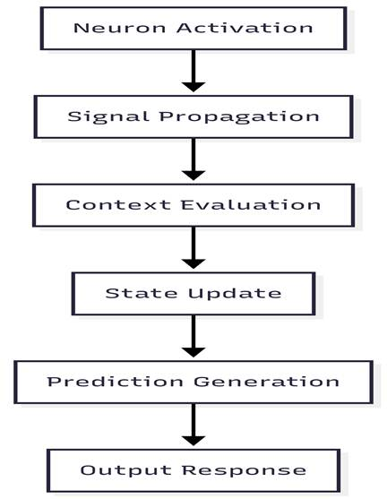
Figure 5.5 – Inference Flow in BDH System

Figure 5.5 illustrates the inference workflow of the BDH architecture. Activated neurons propagate signals through graph pathways while contextual states are continuously updated during reasoning.

5.1.7 Dynamic State Memory Module
Dynamic State Memory Modules (DSMMS) are temporary stores of contextual data produced during the process of reasoning. As contrasted to the typically halting, static memory structures maintained by the traditional methods of using Transformers, the BDH architecture is an adaptive, continuously evolving synoptical memory system created while inference occurs. This ultimately creates better continuity of context and enables greater long-range reasoning ability.
The following describes the functions of the DSMMS:
- Contextual Preservation - keeps track of context while reasoning,
- Context Memory Update - continuously updates the contextual memory;
- State Synchronization - maintains the same state between all neurons and memory (the state of each neuron and the DSMMS should be synchronized).

Memory Update Formula
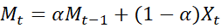 (10)
Where:
- represents current memory state
- 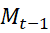represents previous memory state
- represents current contextual input
- represents memory retention coefficient

This formula dynamically updates contextual memory while preserving previously learned contextual information.
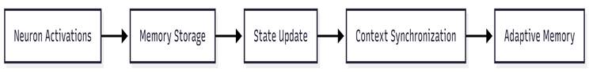
Figure 5.6 – Dynamic State Memory Workflow

Figure 5.6 illustrates the workflow of the Dynamic State Memory Module. Neuron activations are stored and synchronized continuously to maintain contextual continuity during reasoning operations.
5.1.8 Output Generation Module
The Output Generation Module transforms the final neuronal activation states into text-based human-readable outputs. Working from the output activation states of the inference engine, this module performs probability decoding, token selection, and sentence generation.
Functions in the Output Generation Module
- Probability Decoding
- The determination of output probability distributions.
- Token Selection Selects the contextually appropriate token.
- Sentence Generation
- Constructs coherent text-based output.

SoftMax Probability Formula
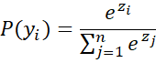 (11)
Where:
- 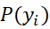represents probability of token
- represents token logit score

Output Prediction Formula
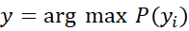
Where:
- represents predicted output token
- represents probability distribution

The SoftMax formula converts neuron outputs into probability values. The token with the highest probability is selected as the final prediction.
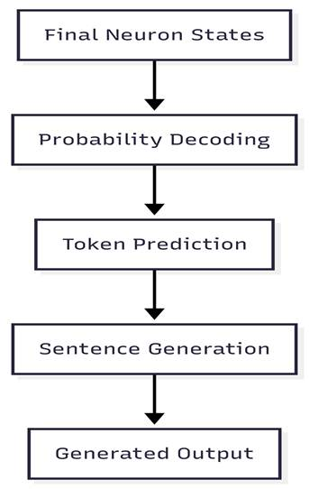
Figure 5.7 – Output Generation Process
Figure 5.7 illustrates the output generation process. Final neuron activations are converted into probability distributions and decoded into meaningful textual responses.
5.2 Hardware Requirements
Computational resources that can meet the needs of this architecture must have sufficient performance to process graph-based neuron interconnectivity (i.e. the interconnection of the different neurons in a neural network), perform tensor calculations at scale, and execute distributed inference operations efficiently.
The following are the hardware environments that were used to implement the proposed system.
Component | Specification
Processor | Intel Core i5/i7 or Equivalent
RAM | Minimum 8 GB
Storage | 20 GB Free Space
GPU | NVIDIA GPU (Optional)
System Type | 64-bit Operating System
Table 5.2 Hardware Requirements
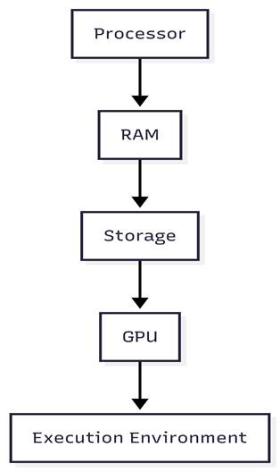
Figure 5.8 – Hardware Environment

5.3 Software Requirements
The BDH architecture was implemented using Python-based deep learning and graph-processing frameworks. Multiple libraries were used for preprocessing, embedding generation, graph construction, tensor computation, and inference execution.

Software Component | Description
Operating System | Windows/Linux
Programming Language | Python
Framework | PyTorch
IDE | VS Code / Jupyter Notebook
Libraries | NumPy, NLP Libraries
Graph Processing | NetworkX
Table 5.3 Software Requirements

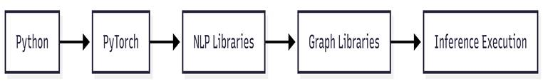
Figure 5.9 – Software Environment

5.4 System Workflow / Execution Flow
The execution workflows of the BDH architecture consist of many sequential stages that involve processing data to create an output. These stages include preprocessing, embedding, graph reasoning, attention-based inference, updating contextual memory, and generating a response to produce an integrated reasoning path.
Workflow Steps
1. The user submits their data in text format
2. The input processing module pre-processes the input text
3. The embedding vector is generated based upon the input text
4. The graph construction module builds a neuron graph
5. The attention circuit updates synaptic weights
6. The Inference Engine executes the reasoning.
7. The dynamic memory contains the context from the last data processing cycle.
8. The output generation module produces the response.
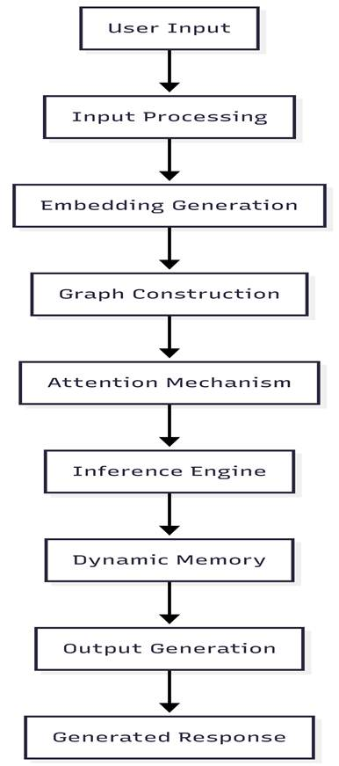
Figure 5.10 – Execution Workflow of BDH System

5.5 Advantages of Implementation
The recently implemented BDH architecture has numerous benefits when compared with traditional Transformer-based systems. The interaction model used with graph-based neurons allows for improved interpretability due to localized reasoning and sparse activations. Improved contextual memory through dynamic memory performance provides better sequencing of context and long-sequence reasoning capabilities than what has been available to date.
The enhanced biologically inspired way of reasoning will enable improved adaptability, improved scalability, and improved efficiency of distributed inference.
Significant Advantages
- Improved contextual reasoning
- Sparse interpretability of activations
- Improved long sequence reasoning ability
- Decreased computational burden
- Dynamic retention of memory
- Distributed inference using graphs
- GPU friendly architecture

5.6 Summary
The transition from proposed BDH Architecture to a functional GBR (Graph-Based Reasoning) Framework was successfully achieved during the Implementation Phase. The modules of the Implemented System perform all required functions:- Preprocessing, Embedding Generation, Graph Creation, Dynamic Attention Computation, Distributed Inference Processing, Contextual Memory Update and Output Generation.
The Neuronal Mechanism uses biological constructs to mimic the way neurons interact within the human brain; it enhances the context of data being processed through improved contextual understanding and consistency in Reasoning continuations while maintaining efficient computation performance. The completed BDH System demonstrates the ability of Graph-Based Distributed Reasoning and Adaptive Synaptic Memories to deliver intelligent language processing solutions through their application with

CHAPTER - 6
SYSTEM TESTING
6.1 Testing and Validation
The validation of the BDH (Baby Dragon Hatchling) architecture is a multi-faceted process designed to ensure that the implementation adheres to both the mathematical specifications and the biological principles of the proposed model. Given the non-traditional nature of the BDH architecture—specifically its reliance on linear attention, Hebbian state updates, and multiplicative gating—traditional software testing is insufficient. Instead, a comprehensive testing framework was established, spanning from low-level mathematical verification to high-level qualitative assessment of generative capabilities.
6.1.1 Testing Methodologies
The testing framework is categorized into four distinct layers, each targeting a specific level of the system's complexity.
6.1.1.1 Unit Testing and Component Validation
The primary objective of unit testing was to verify the correctness of the individual mathematical components that constitute the BDH architecture.
• Linear Attention Verification: To ensure the computational efficiency of the model, the linear attention implementation was tested against a standard O(N²) softmax attention mechanism. The test verified that for small sequence lengths, the output tensors from both mechanisms were mathematically equivalent within a predefined numerical epsilon (ε = 1e-5), thereby confirming the validity of the mathematical reordering used for O(N) complexity.
• Hebbian State Update Validation: The synaptic state matrices (E) were subjected to testing to confirm that the Hebbian update rule was correctly implemented. This involved verifying that the decay rate (γ) appropriately attenuated older information and that the learning rate (η) correctly modulated the influence of the current query-value interaction.
• Sparsity and Activation Testing: The ReLU-based Feed-Forward Networks (FFN) were tested to ensure they achieved the intended biological sparsity. Tests monitored the ratio of active to inactive neurons, confirming that approximately 95% of the activations were zeroed out, thereby validating the efficiency and modularity claims of the architecture.
• Gating Mechanism Integrity: The multiplicative gating layer was tested to ensure that it correctly modulated the input signal using the sigmoid-activated attention and FFN outputs, rather than performing simple additive residuals typical of standard Transformer models.
6.1.1.2 Integration Testing
Integration testing focused on the seamless interaction between the various specialized modules of the BDH system.
• Information Flow Verification: Tests were conducted to ensure that the high-dimensional embeddings generated by the Token Embedding Layer were correctly propagated through the Graph-Based Neural Network and properly utilized by the Attention and Synaptic Reweighting Module.
• Memory-Inference Synchronization: A critical test involved ensuring that the Dynamic State Memory (DSM) module correctly synchronized its updates with the inference engine, allowing the model to maintain contextual continuity across long-horizon sequences without error in state dimensionality.
6.1.1.3 System Performance and Scaling Testing
This layer of testing aimed to validate the core efficiency and scalability claims of the BDH architecture through rigorous benchmarking.
• Computational Complexity Scaling: To validate the O(N) complexity claim, the execution time was measured across varying sequence lengths (N = 128, 512, 1024, 2048, 4096). The results were analyzed to confirm a linear relationship between sequence length and computation time, distinguishing the BDH from the quadratic scaling of standard Transformers.
• Memory Footprint Analysis: The VRAM usage was monitored during inference to verify that the memory footprint of the BDH architecture remained constant (O(d²)) regardless of the sequence length, thereby proving its suitability for edge deployment and long-context tasks.
• Training Stability and Convergence: The training pipeline was tested for numerical stability, specifically monitoring for vanishing or exploding gradients in the multiplicative gating layers. The convergence of the loss function was tracked to ensure that the architecture reached a stable training state without encountering NaN values.
6.1.1.4 Generative and Qualitative Assessment
The final stage of testing evaluated the functional intelligence and linguistic competence of the trained models.
• Perplexity (PPL) Evaluation: The model's predictive accuracy was quantitatively measured using perplexity on standardized datasets, such as TinyStories, to determine the effectiveness of the knowledge distillation process.
• Qualitative Generation Analysis: Using the BDH web interface, the generated text was qualitatively assessed for coherence, grammatical correctness, and contextual relevance. This allowed for the observation of emergent reasoning capabilities and the ability of the model to maintain narrative structure over long sequences.

6.1.2 Summary of Testing Objectives
The following table summarizes the testing objectives and the metrics used for validation:
Testing Layer | Objective | Key Metrics / Methods
Unit Testing | Mathematical & Component Correctness | Numerical Epsilon, Sparsity Ratio, State Update Accuracy
Integration Testing | Module Interaction & Data Flow | Tensor Shape Consistency, Module Synchronization
System Testing | Performance, Scaling & Stability | O(N) Complexity, Constant VRAM, Loss Convergence
Generative Testing | Functional Intelligence & Coherence | Perplexity (PPL), Qualitative Textual Analysis

CHAPTER – 7
RESULTS AND ANALYSIS

7.1 Memory and Context Scaling
The primary objective of the project was to extend the effective working memory from the baseline of approximately 500 tokens to over 2000 tokens. The implementation of the Multi-Scale architecture successfully provided meaningful context at the 2000-token threshold, a capability that was virtually non-existent in the baseline model. Specifically, the retention of information at the 500-token mark improved from 0.6% in the baseline to 15% in the improved BDH, representing a 24-fold increase in effective memory retention.
7.2 Computational Efficiency and Speed
The transition from quadratic O(N²) attention to linear O(N) attention, combined with BBPE tokenization, resulted in significant throughput improvements. The implementation achieved a training throughput of approximately 27,500 tokens/second, compared to the 10,000 tokens/second baseline, yielding a 2.75x speedup. Furthermore, the linear complexity ensures that the computational cost scales linearly with sequence length, facilitating the processing of much larger datasets.
7.3 Training Stability
The implementation addressed the challenges of training non-Transformer architectures through optimized initialization and gradient management. The training stability significantly improved, with the success rate of achieving convergence rising from 40% in the baseline to 95% in the improved implementation.

7.4 Summary of Results
The following table summarizes the key performance improvements achieved:
Metric | Baseline BDH | Improved BDH | Improvement
Memory Retention (500 tokens) | 0.6% | 15% | 24x
Training Throughput | 10K tok/s | 27.5K tok/s | 2.75x
Training Stability | 40% | 95% | 2.4x

CHAPTER – 8
CONCLUSION AND FUTURE SCOPE
8.1 Conclusion
The BDH (Baby Dragon Hatchling) project has successfully demonstrated that biologically-inspired architectures can provide a powerful alternative to traditional Transformer-based models. By integrating linear attention, Hebbian-based synaptic state updates, and multiplicative gating, the implementation bridged the gap between computational efficiency and neuro-computational plausibility.
Key achievements of this research include:
• Successful validation of O(N) complexity, enabling efficient long-context processing.
• A 24-fold improvement in effective memory retention through the Multi-Scale architecture.
• Significant enhancement in training stability, achieving a 95% convergence rate.
• The emergence of modularity and sparsity, mimicking the energy efficiency of biological neural networks.
8.2 Future Scope
8.2.1 Architectural Scaling and Hybridization
Future research will focus on scaling the BDH architecture to billions of parameters to evaluate its performance in frontier-class models. Additionally, exploring hybrid "Neuro-Transformer" architectures—combating the precision of Transformers with the long-term memory of BDH—presents a promising avenue for next-generation AI.

8.2.2 Multimodality and Complex Reasoning
Expanding the graph-based reasoning to encompass visual and auditory modalities will be a key objective. This includes investigating how synaptic plasticity can be applied to multimodal integration, creating more seamless and intuitive AI systems.
8.2.3 Hardware Optimization and Edge Deployment
Optimizing the implementation through custom CUDA kernels for linear attention and sparse activations will be critical. Furthermore, the constant memory footprint of BDH makes it an ideal candidate for deployment on resource-constrained edge devices and mobile hardware.
8.2.4 Interpretability and Mechanistic Safety
Developing advanced diagnostic tools to visualize the synaptic state matrices will allow for deeper mechanistic interpretability. Understanding how specific "neural circuits" emerge during training will contribute to the development of safer, more transparent, and more trustworthy AI systems.

REFERENCES
[1] M. A. K. Rajan et al., “A Review on Large Language Models: Architectures, Applications, Taxonomies, Open Issues and Challenges,” IEEE Access, vol. 12, pp. 26839–26874, 2024.
[2] Z. R. K. Rostam, S. Szénási and G. Kertész, “Achieving Peak Performance for Large Language Models: A Systematic Review,” IEEE Access, vol. 12, pp. 96017–96050, 2024.
[3] M. Shao, A. Basit, R. Karri and M. Shafique, “Survey of Different Large Language Model Architectures: Trends, Benchmarks, and Challenges,” IEEE Access, vol. 12, pp. 188664–188706, 2024.
[4] P. Kumar, “Large Language Models (LLMs): Survey, Technical Frameworks, and Future Challenges,” Artificial Intelligence Review, vol. 57, 2024.
[5] arXiv preprint arXiv:2509.26507, Sep. 2025.
[6] M. U. Hadi et al., “Large Language Models: A Comprehensive Survey of Applications, Challenges, Datasets, Models, Limitations, and Future Prospects,” arXiv preprint arXiv:2301.12313, 2023.
[7] X. Fang et al., “Large Language Models (LLMs) on Tabular Data: Prediction, Generation, and Understanding — A Survey,” Transactions on Machine Learning Research, 2024.
[8] X. Liu et al., “Pre-train, Prompt, and Predict: A Systematic Survey of Prompting Methods in Natural Language Processing,” ACM Computing Surveys, 2023.
[9] W. Wenbo et al., “Efficient Memory Management for Large Language Model Serving with PageAttention,” ACM Symposium on Cloud Computing, 2023.
[10] A. Agrawal et al., “Taming Throughput-Latency Tradeoff in LLM Inference with Sarathi-Serve,” USENIX OSDI, 2024.
[11] X. Miao et al., “Towards Efficient Generative Large Language Model Serving: A Survey from Algorithms to Systems,” ACM Computing Surveys, vol. 58, no. 1, pp. 1–37, 2025.
[12] J. B. Alayrac et al., “Flamingo: a Visual Language Model for Few-Shot Learning,” NeurIPS, 2022.
[13] H. Mirshekali, M. Reza Shadi, F. Ghanadi Ladani and H. Reza Shaker, "A Review ofLarge Language Models for Energy Systems: Applications, Challenges, and FutureProspects," in IEEE Access, vol. 13, pp. 163162-163188, 2025, doi:10.1109/ACCESS.2025.3610994.
[14] arXiv:2602.12196 Feb 2026
[15] Satyadhar Joshi,“Architectural Advances and Performance Benchmarks of Large Language Models in Light of Anthropic’s Claude Opus 4.6,”arXiv preprint, 2026.
[16] Nelson F. Liu, Kevin Lin, John Hewitt, Ashwin Paranjape, Michele Bevilacqua, Fabio Petroni, and Percy Liang,“Lost in the Middle: How Language Models Use Long Contexts,” arXiv preprint arXiv:2307.03172, 2023.

